Ocean Adventure Field
Build a Cow

Time: 12 minutes
Group Size: 10-15 students
Grade Levels: 3rd – 8th grade
Location: Samueli

OVERVIEW OF ACTIVITY

In this station, students will learn the difference between terrestrial and marine mammals. They will compare the skeletons of a gray whale and a cow to determine the similarities and differences between terrestrial and marine mammal adaptations.

PERFORMANCE OBJECTIVES

Students will be able to:
- Compare gray whale and cow anatomy to determine specific adaptations.
- Observe skeletal anatomy to determine animal adaptations.
- Construct a cow skeleton using a gray whale skeleton as a reference.
- Understand the similarities and differences between terrestrial and marine mammals.

CHALLENGE

Using Graysea as a model for comparison, build a cow skeleton on the ground.

MATERIALS

- Cow bones
- Graysea skeleton
- Laminated diagrams of various mammal skeletons (cow and sea lion)

ADVANCE PREPARATION

- Pull out the bones and place them in the center of the room, close enough to Graysea so the students can observe and compare.
- Place the laminated skeleton sheets to the side so the students cannot see them until later in the activity.

PROCEDURE

Engage:
- A Whale is a mammal. What are some of the challenges for mammals that live in water? (Breathing air; having babies; swimming (legs are not efficient); finding food (water not clear, cannot see far), getting cold (water better conductor of heat away from body))
- What are some of the adaptations of marine mammals to water habitat? If they do not say anything try asking what they would have problems with if they were thrown in the water and had to live there.
- We will be looking at skeletal adaptations to compare what is similar and what is different.

Explore:
- Hand out cow bones, more than one per student. Do not show picture of skeletons, until they have tried to work it out on their own.
- Let them try to work it out. If they need help, you can ask the students questions to guide them:
  - Look at your bone. What bone is it or where is it on Graysea?
  - Where should you start? (head)
  - What is next?
  - Look at each other’s bones. Do you have similar bones? What might fit together?

Explain:
- Which bones did you put together for the legs? How do they fit together? Discuss the differences between hinge and ball joints.
- Which bones did you put together for the vertebrae/spine? Why? You may want to show the students a few different looking vertebrae to show the difference in flexibility along the backbone.
- Which bones do you see in both skeletons?
- Which bones do you only see in one skeleton? Which skeleton do you see it in? Why only in that animal and not the other?
  - What bones does Graysea have that the cow doesn’t have? What are they?
  - What bones does the cow have that Graysea doesn’t have? What are they?
- What type of adaptations do you think Graysea has in order to survive in an ocean habitat? Why were these changes from terrestrial mammals needed? Why did some not have to change?

ACTIVITY RESOURCES

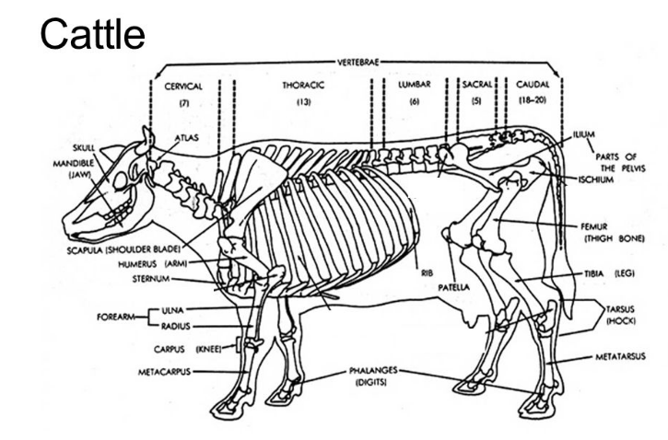
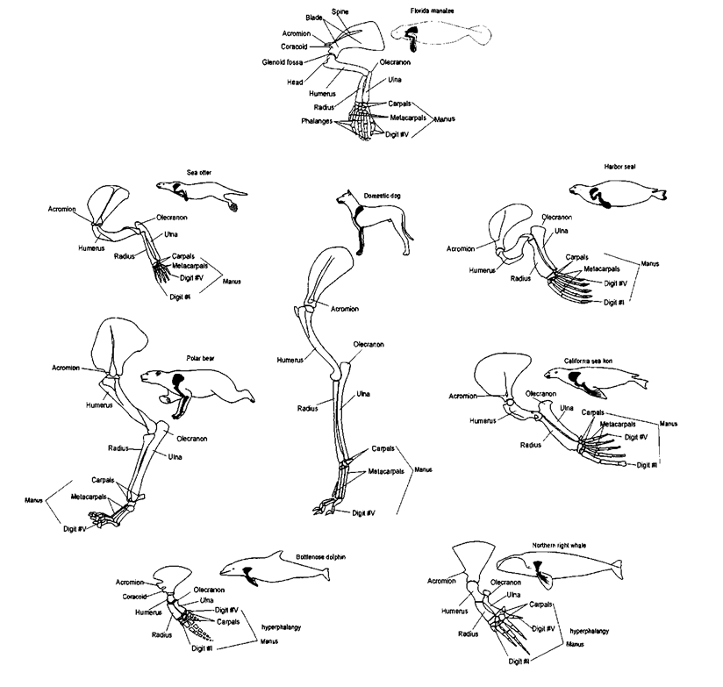
Mammal Forelimbs

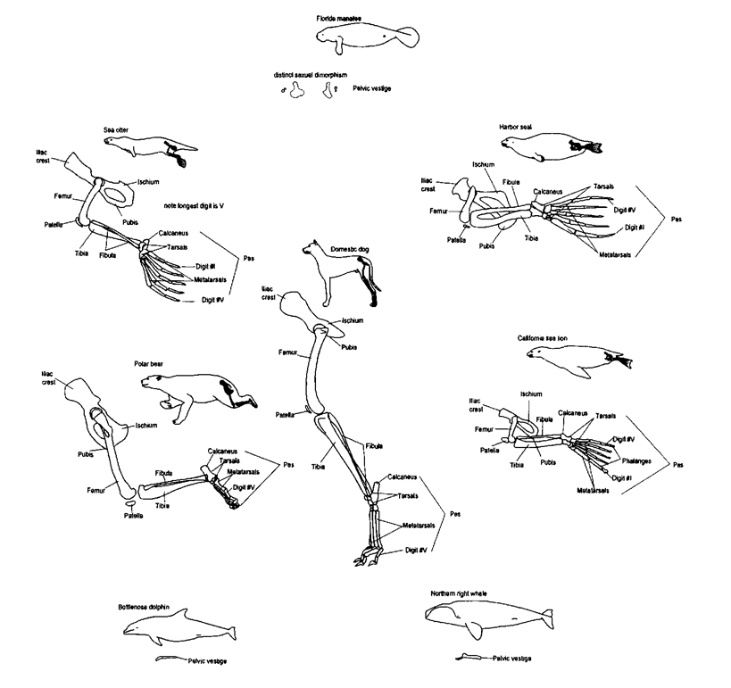
Mammal Pelvic Appendages (Hindlimbs)

Mammal Axial Skeletons

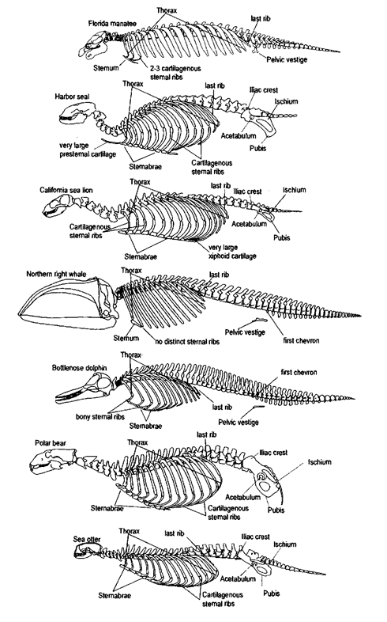

BACKGROUND INFO

http://what-when-how.com/marine-mammals/skeletal-anatomy-marine-mammals/

